Mixtures provided similar benefits to nitrogen yield under grazing and under mowing
Huguenin-Elie O.¹, Husse S.^{1,2}, Buchmann N.² and Lüscher A.¹
¹Agroscope, Institute for Sustainability Sciences, Reckenholzstrasse 191, CH-8046 Zürich
²Institute of Agricultural Sciences, ETH Zürich, Universitätstrasse 2, CH-8092 Zürich
Abstract
Previous studies showed benefits of mixing species with complementary characteristics related to nitrogen (N) capture on phytomass and N yields of mown grassland. Grazing instead of mowing may impact soil properties and the interactions between plant species. This study aimed at determining whether grazing modifies the benefits of mixtures on N yield compared to mowing. The design included N₂ fixing and non-fixing species, as well as shallow- and deep-rooting species. Lolium perenne monoculture and mixtures with Cichorium intybus, or/and Trifolium repens and T. pratense were compared under grazing or mowing for their N yield and capture of fertilizer and atmospheric N. Mixtures of the N₂ fixing and the non-fixing species yielded as much N as the L. perenne monoculture fertilized with 2.4 times more N, showing the tremendous benefit of mixtures for N efficiency. The addition of the deep-rooting C. intybus did not lead to a significantly larger N capture. The benefits of the mixtures on N yield were similar under grazing and mowing. Grazing did not modify the proportion of N derived from fertilizer and symbiotic fixation in the plants. We conclude that grass-legume mixtures are effective in improving N efficiency under both mowing and grazing.
Keywords: multispecies swards, mixture effect, nitrogen yield, grazing
Introduction
Recent studies showed that mixing grasses and legumes clearly benefits phytomass and nitrogen (N) yields in fertilized swards managed under mowing (Suter et al., 2015). Complementarity between N₂ fixing and non-fixing species (Nyfeler et al., 2011), as well as temporal and vertical niche differentiation are processes involved in the mixture effects benefiting productivity and nutrient capture of multispecies swards (Husse et al., 2017). But grazing may modify these processes as compared to mowing by its effects on plant growth, nutrient availability and spatial redistribution in the soil, as well as on soil compaction (Bilotta et al., 2007). The effects of mixing grass, forb and legume species on nutrient capture might therefore differ markedly under grazing and mowing. On the other hand, data from a previous study indicated that the relative advantage for phytomass production of a four-species grass-legume mixture as compared to a Lolium perenne monoculture was similar when grazed and when cut (Collins et al., 2014). The objective of our study was to determine whether grazing modifies the benefits of multispecies swards on N yield as compared to mowing.
Materials and methods
Rotational grazing with heifers and mowing (management types) were compared on five sward types in a split-plot design, with the sward type as main plot and the management type as subplot. This design is especially powerful for testing the interaction between management type and sward type. The subplots under mowing were cut at the start of each grazing period. The five sward types were: 1) monoculture of Lolium perenne (MonoLp), 2) mixture of Lp and Cichorium intybus (LpCi, 2/3 Lp + 1/3 Ci), 3) mixture of Lp, Trifolium repens and Trifolium pratense (LpTrTp, 2/3 Lp + 1/6 Tr + 1/6 Tp), 4) mixture of Lp, Ci, Tr and Tp (LpCiTrTp, 2/3 Lp + 1/9 of each of the other species), and 5) monoculture of Lp fertilized with 2.4 times more N than the other sward types (MonoLp_HN, fertilization of 350 kg N ha⁻¹ year⁻¹). The four species were selected for their differences in N₂ fixing ability and rooting depth (non-fixing: Lp and Ci, fixing: Tr and Tp, shallow-rooting: Lp and Tr, deep-rooting Ci and Tp). In the grazed plots, the yield was estimated by measuring the height of the swards before and after grazing with a rising plate meter (83 measurements per plot). The N derived from fertilizer application (Nfert) and symbiotic N₂ fixation in Tr and Tp (Nfix) were measured using ¹⁵N-labelled fertilizer applied on subplots. The N derived from the soil (Nsoil) was calculated as the difference between the total N content and the sum of Nfix and Nfert. The data were analysed by ANOVA.
Results and discussion
The dry matter yields of the LpTrTp and the LpCiTrTp mixtures were significantly larger than those of the MonoLp sward (+47% on average over the grazing and mowing management; Table 1). This difference was +78% for the total N yield. These two mixtures even equalled the yield of the highly fertilized L. perenne monoculture (MonoLp_HN). This confirms the tremendous benefit of grass-legume mixtures as compared to grass monocultures in terms of N efficiency. The interaction between the sward and the management types was not significant for either dry matter or total N yield (Table 1), which shows that the benefit of the mixtures on dry matter and N yield was similar under grazing and mowing. The addition of the deep-rooting C. intybus in the swards did not lead to a significantly larger N capture (LpCi versus MonoLp, and LpCiTrTp versus LpTrTp), indicating that the observed mixture effect on N yield was mainly due to symbiotic N₂ fixation and not to vertical niche differences in N uptake from the soil.

Table 1. Effect of the sward types on the dry matter and the total nitrogen yield. The data are the average of 3 experimental years. The average of both management types is shown as the interaction between sward and management types is not significant. SE: standard error of the mean. Means followed by a common letter are not different at the 5% level (Duncan MRT).
Sward type | N fertilisation  (kg N ha⁻¹ yr⁻¹) | Dry matter yield  (kg ha⁻¹ yr⁻¹) |  |  | Total N yield  (kg ha⁻¹ yr⁻¹)
Monoculture MonoLp | 145 | 4.7 | a |  | 118 | a
Mixture LpCi | 145 | 5.7 | b |  | 142 | a
Mixture LpTrTp | 145 | 6.8 | c |  | 206 | b
Mixture LpCiTrTp | 145 | 7.0 | c |  | 213 | b
Monoculture MonoLp_HN | 350 | 6.7 | c |  | 225 | b
SE |  | 0.4 |  |  | 13
P-value ANOVA
Sward type |  | <0.05 |  |  | <0.01
Management type |  | <0.01 |  |  | <0.01
Interaction |  | 0.88 |  |  | 0.67

In each of the four species of the LpCiTrTp mixture, the total N content in the harvested phytomass, as well as its components (Nfert, Nsoil and Nfix), were similar under grazing and mowing (Figure 1). Thus, although grazing induced compaction of the upper soil layer (0-6 cm soil depth; data not shown), it did not modify the ratio of N derived from symbiotic fixation, fertilizer or the soil in the different species. The absence of a negative effect of grazing on symbiotic N₂ fixation by legumes probably contributed to the similar mixture effects under the two managements.

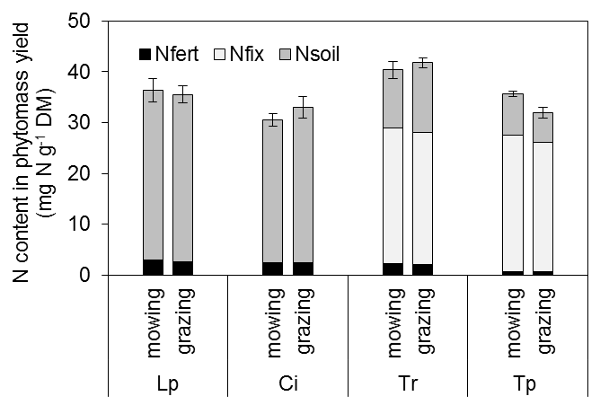
Figure 1. Nitrogen content in the harvested phytomass of each species of the mixture with L. perenne (Lp), C. intybus (Ci), T. repens (Tr) and T. pratense (Tp) managed under mowing or grazing. Total N content is divided in N derived from the fertilizer (Nfert), N derived from N₂ fixation (Nfix) and N derived from the soil (Nsoil). The data show the mean of two regrowths and the error bars the standard error of the mean.

Conclusion
As compared to a L. perenne monoculture, the benefits of multispecies swards on phytomass and N yield were equally impressive under grazing and mowing. We conclude that grass-legume mixtures are effective for improving N efficiency under both mowing and grazing.

Acknowledgement
The research leading to these results received funding from the European Community’s FP7 Programme under grant agreement no. 244983 (Multisward).

References
Bilotta G.S., Brazier R.E. and Haygarth P.M. (2007) The impacts of grazing animals on the quality of soils, vegetation, and surface waters in intensively managed grasslands. Advances in Agronomy 94, 237-280.
Collins R.P., Delagarde R. and Husse S. (2014) Biomass production in multispecies and grass monoculture swards under cutting and rotational grazing. Grassland Science in Europe 19, 719-721.
Husse S., Lüscher A., Buchmann N., Hoekstra N.J. and Huguenin-Elie O. (2017) Effects of mixing forage species contrasting in vertical and temporal nutrient capture on nutrient yields and fertilizer recovery in productive grasslands. Plant and Soil 420, 505-521.
Nyfeler D., Huguenin-Elie O., Suter M., Frossard E. and Lüscher A. (2011) Grass-legume mixtures can yield more nitrogen than legume pure stands due to mutual stimulation of nitrogen uptake from symbiotic and non-symbiotic sources. Agriculture, Ecosystems & Environment 140, 155-163.
Suter M., Connolly J., Finn J.A., Loges R., Kirwan L., Sebastià M.-T. and Lüscher A. (2015) Nitrogen yield advantage from grass-legume mixtures is robust over a wide range of legume proportions and environmental conditions. Global Change Biology 21, 2424-2438.

