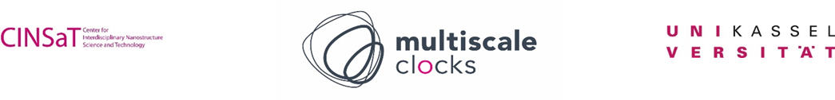

Application form for Start-up Funding

Personal Details
Last name
First names
Date of birth (dd/mm/yyyy)
Gender
Nationality
Country of birth
Country of permanent residence
Contact Details
Street
City
Post code
Country
Phone number
E-mail
Education
University/Colleges attended |  | Dates attended |  |  | Principal subjects studied | Title of Qualification | Overall class/grade & date obtained (or expected)
 |  | From | To
Grants, Funding
English Proficiency (Please underline as appropriate.)
Native speaker / fluent / very good / good / sufficient
Research Area and Research Project
(max 1 page; Please include a clear outline of your research area of expertise and interest and the planned research project)
Publication list
Collaborations
(max ½ page; please list details about collaborations with other researchers, institutions and/or companies)
Financing Plan
(Maximum 73.000 euros allocated for position funding as Postdoctoral Researcher for 6 months and/or consumables as well as conferences; please provide a detailed list of requested funds and respective purpose; funding must be expended by December, 2026)

Please note that we collect application statistics each year. This includes information on gender, age, and university attended. Please contact Dr. Thordis Arnold (multiscale.clocks@uni-kassel.de) if you have any questions about this.

