International Student Exchange
at the University of Kassel
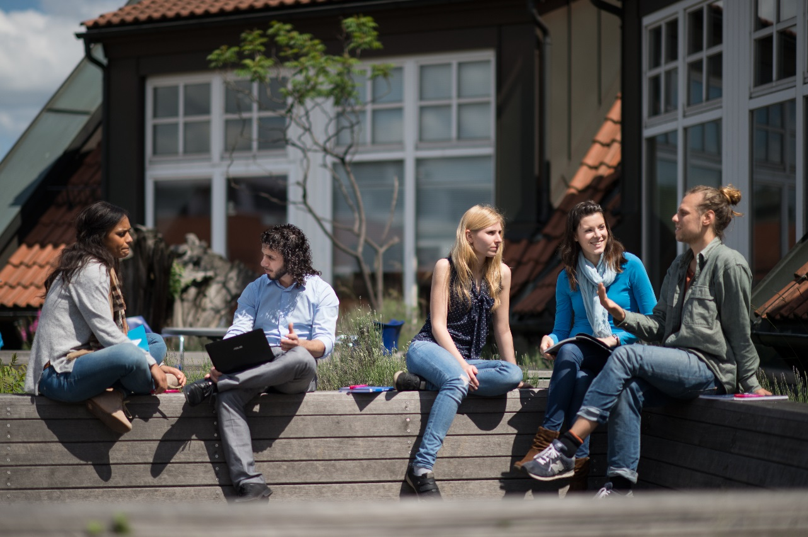
Faculty of ___________________
Summer Term 2018
Welcome Address

Dear students, BEISPIELTEXT
We are very happy to welcome you as our exchange students at the University of Kassel. The Welcome Centre of the University of Kassel is now your first contact point when it comes to organising your stay in Kassel. On our website we prepared all the information you need for a successful start of you studies. To give you a short overview, we summarized the information in this booklet. We hope that this information helps you organise your stay and have a good start here in Kassel.
At the same time, we would like to point out some of our student support offers designed especially for international students:
1) Everybody needs somebuddy: The university offers a buddy programme (http://www.uni-kassel.de/go/buddy). Buddies are students from Kassel who want to help international students like you before you arrive here as well as during your stay.
2) German language: Our Language Centre offers an intensive German language course for two weeks before the start of the orientation week, which is especially designed for exchange students.
3) University Welcome: The university offers an orientation week (O-Woche) especially for international students. During this week, the Welcome Centre and the faculties will welcome you, introduce you to the university and the city of Kassel and help you get in contact with other students and get your studies started.
4) Studying: Our semesters start on October 1st for winter and on April 1st for summer. Lectures start around mid-October and mid-April and have a duration of 3 to 4 months. Exams take place after the lecture period.
We are looking very much forward to seeing you in Kassel. Please do not hesitate to contact us should you have any questions regarding your stay and studies in Kassel.
Prof. ________________,
Erasmus+ Coordinator
Content
1. Information on the University of Kassel and on your arrival in Kassel 4
1.1. Services at the University of Kassel 4
1.2. Steps before Arrival 6
1.3. Steps on Arrival 9
1.4. Orientation Week 13
2. Courses: Summer Term 2018 14
2.1. List of English Courses at BACHELOR Level 14
2.2. List of English Courses at MASTER Level 14
2.3. Learning Agreement 15
2.4. Transcript of Records 15
2.5. Route Card 16
3. Contact persons for courses and course related issues at the Faculty of 18
4. ABC and Abbreviations 21

Information on the University of Kassel and on your arrival in Kassel

Services at the University of Kassel
Address and office hours:

Ms. Johanna Große
Campus Center, Moritzstr. 18, 2nd floor, room 2128a
Phone: +49 561 804-3564
Fax: +49 561 804-3513
Email: welcome-centre@uni-kassel.de
Web: http://www.uni-kassel.de/go/welcome-centre
Mon, Wed, Fri: 1 p.m. - 3 p.m.

Welcome & Registration: Welcome Centre in the International Office
The Welcome Centre in the International Office is the first contact point for international students. The team of the Welcome Centre places special importance on individual and practical assistance and is there to support you extensively before and upon your arrival in Kassel.
Ms. Marlis Fellmann
Campus Center, Moritzstr. 18, 2nd floor, room 2128
Phone: +49 561 804-3075
Fax: +49 561 804-3513
Email: exchange@uni-kassel.de
Web: http://www.uni-kassel.de/go/exchange
Tue, Thu: 1 p.m. - 3 p.m.
The International Office is also in charge of formalities such as application, acceptance, registration as a student, address or major changes etc.

Address and office hours:
Ms. Marlies Otto
Address: Campus Center, Moritzstr. 18, 3rd floor
Phone: +49 561 804-2552
Email: m.otto@studentenwerk.uni-kassel.de
Web: http://www.studentenwerk-kassel.de
Office hours: Mon, Thu: 10 a.m. - 12 p.m.
Tue, Wed: 10 a.m. – 3 p.m.

Accommodation: Studentenwerk Kassel
The Studentenwerk is designed to help students cope with the non-academic parts of student life. They provide food in the student dining halls and cafeterias, assist students in finding housing in dormitories or on the private market, support students with children, and offer legal and social advice as well as counselling. Please find the wide range of services on their website.
Address:
Kurt-Wolters-Str. 5, room 2044
Phone: +49 561 804-3302 / 3689
Telefax +49 561 804-3815
Email: sz@uni-kassel.de
Web: http://www.uni-kassel.de/sprz

Learning German: University Language Center (Sprachenzentrum)
The Language Center offers a variety of programmes and language courses throughout the semester. There are classes from beginning to certificate level, as well as supplementary courses, language tandem programmes, the buddy programme and other foreign language activities. If you need to brush up on your German or want to learn a new language while you are in Kassel, then the Language Centre is the place to go.
Address:
Damaschkestraße 25, 34121 Kassel
Phone: +49 561 804- 5394
Telefax +49 561 804- 5258
Email: hochschulsport@uni-kassel.de
Web: www.uni-kassel.de/hochschulsport

University Sports (Hochschulsport)
All students at the University of Kassel who have paid their semester sports fees are allowed to participate in the sports programmes available through the university. Many different activities are available - from Aerobics and Afro Dance to Volleyball and Zen Mediation.
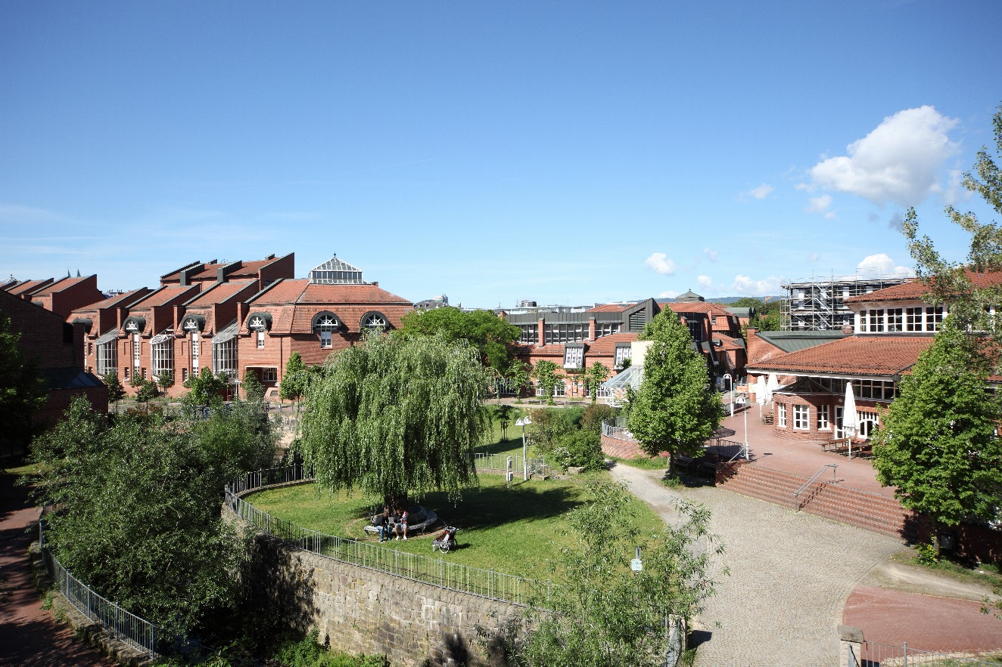

Steps before Arrival
http://www.uni-kassel.de/go/welcome_prepare

Schedule of Courses (Vorlesungsverzeichnis)
Information about courses at the University of Kassel can be found on the internet. The course catalogue for the winter or summer semester will be updated on September 1st and on March 1st. You can check out the schedule of courses (Vorlesungsverzeichnis) on the university website.

German Language Courses
All exchange students can take part in a pre-semester German course. This is a two-week long intensive language course. A fee is required for participation in this course. Please find details on our website.

Visa
As soon as you receive an admission letter from the University of Kassel, you will be able to apply for a visa from the German embassy or consulate in your home country or country of residence. The addresses of German embassies and consulates and information regarding entry requirements can be found on the website of the German Foreign Office. There, you will also find information on the specific requirements for obtaining visa on a country-by-country basis.

Accommodation
Whether you would like to stay in a student hall of residence or in a shared apartment on the private market, cheap accommodation in Kassel is available for those who start searching early. Those who start late will find it difficult to find affordable accommodation. It can often take weeks to find accommodation; therefore, we advise you to start searching as soon as possible.

Health Insurance
In Germany, every citizen is required to have health insurance.
- EU Citizens
If you are a citizen of the EU and you have health insurance coverage in your country of residence, you can get the European Health Insurance Card (EHIC). EHIC is sufficient for your stay in Germany and covers emergency treatments in all German hospitals.
- Non-EU Citizens
If you are a citizen from a country outside of the EU, you will need to provide a health insurance certificate already upon applying for your visa. Please choose a foreign health insurance policy, which covers the beginning of your stay in Germany. Please check whether your policy covers a visit to the doctor and a hospital stay. In most cases, the amount insured must lie between €30,000 and €50,000.

Expenses
The University of Kassel does not charge any tuition fees but so-called social service fees. Exchange students have to pay a reduced fee of about 240 € per semester. In addition, you have to pay for rent, insurance, food, clothes, books, entertainment, and travel. With about 750 € per month, you can live comfortably in Kassel and will still have money left to go to a bar or the movies. There are a number of tips for saving costs when living in Kassel. These include:
- Borrow your books for class from the library and/or copy them at a copy shop;
- Shop at low-cost grocery stores or in second hand shops;
- Go to the movies on Kino-Tag (usually, Monday or Tuesday);
- If you live with others, see if they want to buy big items: microwave, printer, TV, etc. together;
- Show your student ID and you may receive student discounts in museums or recreational facilities;
For further information and tips, ask your buddies or the Welcome Centre tutors before arrival.
Address:
Kurt-Wolters-Str.5, 34125 Kassel
Phone: +49 561 804-7257
Email: buddy@uni-kassel.de
http://www.uni-kassel.de/go/buddy

Buddy Programme
Many things can seem strange and unexpected for an international student, but with a Buddy you start off on the right foot into a successful course of studies. Your Buddy is your personal contact person here at the university, who supports you in dealing with daily routine and study-specific questions at the beginning of your stay in Kassel. Participation in the Buddy Programme helps you to socialize quickly with nice people inside and outside the University and to improve your German language skills. The Buddy Programme is administered by the University Language Centre.

Steps on Arrival
http://www.uni-kassel.de/go/welcome_arrival

Getting here
How do I get to the university? Where can I catch the tram? Where can I park? And where can I find the Admissions Office or the International Office? Directions and maps of our campuses make getting around a lot easier. Find them on our website.

Moving In
- Student Halls of Residence
If you are moving in to one of the student halls of residence, please go to the Studentenwerk office in the Campus Center, 3rd floor.
Mon to Fri: 10:00 - 12:00.
If you will be arriving at other times, please make an alternative appointment for moving in.
- Private Rentals
Before your arrival, arrange a date and time of moving in with your landlord or flatmates. You should know your arrival time and have a telephone number on hand just in case you are delayed.
- Rental confirmation from landlord
When moving in the landlord or owner must sign a so called rental confirmation ("Wohnungsgeberbestätigung"), which you will need to show at the registration with the Citizens' Office. We recommend to print out the form and ask the landlord to sign it on the day of moving in. Please download the form here: https://tinyurl.com/hrocur6

Address and office hours:
Residence Registration Office at the City Hall:
Obere Königsstr. 8, 34125 Kassel
Mon 08:00 - 18:00 (by appointment);
Tue 08:00 - 14:00;
Wed 08:00 - 18:00 (by appointment);
Thu 08:00 - 14:00;
Fri 08:00 - 12:30;
Sat 09:00 - 12:00 (by appointment)

Residence Registration Office at the University:
Moritzstr. 18 (3rd floor), 34127 Kassel
Campus Center, room 3114
Wed 08:30 - 12:00 (by appointment only)

Residence Registration
As legally required you must go to the Residence Registration Office (Bürgeramt) in the Town Hall (Rathaus) and let them know your address in Kassel. This must be done within one month after your arrival in Kassel. You simply go in, receive a number from the information desk, and, when your number is called, you fill in the form with the help of a person who works there.
You will be given a copy of this form. Keep it in a safe place. You will need this form to get your residency permit, to open a bank account, to get a library card, etc.
If you move to another apartment in Kassel during your studies, you need to tell the Residence Registration Office your new address.

Bank Account
In order to pay bills or your rent, you will need an account with one of the German banks. When you have opened your bank account (also called Girokonto) you will receive a bank card. You will be able to use this card as a method of payment in the majority of shops or alternatively use it to draw money from ATMs.
If you work in Germany your wage will also be transferred directly onto your bank account.
You can open an account at a range of different banks. Ask whether there are special conditions for students, as the service and handling charges are often different.

Health Insurance
If you have a health insurance certificate from your insurance provider in your country of residence, for example by the European Health Insurance Card (EHIC) or a certification thereof, a German health insurance provider can confirm that you are exempt from the domestic duty to obtain insurance. Such a confirmation can be issued by any public health insurance provider in Germany.
If you need additional insurance, take out a health insurance policy, for example, with one of the public health insurance companies.

Student ID
You have to officially enrol at the University of Kassel. Enrolment for exchange students for the coming summer semester takes place on April 3rd 2018 in the Welcome Centre.
Please be in the Welcome Centre between 10 and 11 a.m. that day. You will receive all necessary documents and information about enrolment there. You will then receive your student ID in the afternoon on that day.
Address and office hours:
Mönchebergstraße 11 (next to the TorCafé)
https://www.uni-kassel.de/its
Mon-Fri: 8 a.m. - 10 p.m.;
Sat: 9 a.m. - 4 p.m.

Computer rooms:
Mönchebergstraße 11
Rooms: 180, 190, 220, 240, 250
Mon - Fri: 8 a.m. - 10 p.m.;
Sat: 9 a.m. - 3:45 p.m.

Internet on Campus
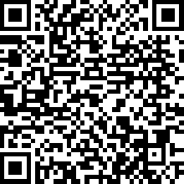
If you bring your own computer from home, are renting one from the IT Service Centre, or just want to use the internet on campus, you need to contact the IT Service Centre (also ITS). With your Student ID you will receive a user name and password. You can then log-on to the internet in the student housing or sign-on to a computer in the available computer rooms on campus.
Should you have problems with your internet connection at the dorm, stop by the first floor at the ITS or contact the IT advisors at the Studentenwerk.

CampusCard
The main library of the University of Kassel is located right in the middle of the campus Holländischer Platz (HoPla). In order to borrow books from the library, you need the CampusCard. You can apply for one at the main library, but it will take a couple of days until you receive it. Bring your passport and a copy of the certificate you received at the Resident Registration Office. Website: http://www.uni-kassel.de/go/campuscard.
Address and office hours:
The Foreigners' Registration Office Kassel:
Kurt-Schumacher-Straße 29, 34117 Kassel
Mon, Thu 8:30 a.m. - 12:30 p.m.;
Tue, Fri 8:30 a.m. - 12:30 p.m. (by appointment);
Wed 2 p.m. - 5:30 p.m. (by appointment);

On-campus Office Hours of the
Foreigners' Registration Office:
Campus Center, Moritzstr. 18, 3rd floor, room 3114
Tue: 08:30 a.m. - 12:00 p.m. and
Wed: 08:30 - 12:00 (by appointment only)

Visa Information:
Campus Center, Moritzstr. 18, 2nd floor,
room 2128a
Phone: +49 561 804-3564
Fax: +49 561 804-3513
Email: visa-info@uni-kassel.de
http://www.uni-kassel.de/go/visa
Tue and Thu: 1 p.m. - 3 p.m.

Residence Permit
The Foreigners’ Affairs Office is where you will need to apply for a residency permit.

On-campus Office Hours of the Foreigners' Registration Office
The Foreigners' Registration Office offers on-campus office hours on a regular basis. Please make sure to arrange an appointment beforehand by phone or e-mail.

Visa Information
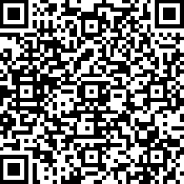
If you have questions concerning the application or extension of your visa, please feel free to contact the Visa Information Service, a service provided by the Welcome Centre and the Admissions Office.

Address and office hours:
Welcome Centre
Campus Center, Moritzstr. 18, 2nd floor
room 2128a
Phone: +49 561 804-3564
Fax: +49 561 804-3513
Email: welcome-centre@uni-kassel.de
Web: www.uni-kassel.de/go/oweek
Mon – Fri: 10 a.m. – 6 p.m. (03.04. – 07.04.2018)

Orientation Week
The University of Kassel offers a special programme for supporting international first semester students and researchers. Student advisors organize an introductory orientation week before courses officially start to support international students and researchers in successfully transitioning into their studies or research.
The orientation week begins with a formal welcome, after which you will be guided and supported by tutors in learning about studying and researching at the University of Kassel. During this week, you will also get to know other international students and university staff.
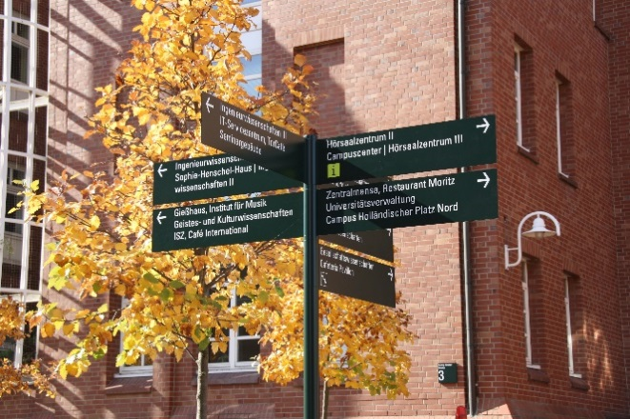
The Orientation Week in the summer semester 2018 takes place between
April 3rd and April 7th 2018.

Courses: Summer Term 2018 BEISPIEL

2.1. List of English Courses at BACHELOR Level

2.2. List of English Courses at MASTER Level

2.3. Learning Agreement

2.4. Transcript of Records

2.5. Route Card
- This route card will help you make a good start here at our faculty.
- We encourage you to go to the first sessions of all courses you think about going to. Take one or two sessions to get an impression of the courses before you choose the courses you want to acquire credits in.
- Please see the contact people in your faculty (page 20) to discuss your choice of courses. They can give you valuable hints and help you choose the most suitable courses. They can also provide you with very helpful advice regarding your learning strategy and help you to keep track of the administrative steps to follow. Please choose your courses before May 15.

Title of the course and  teacher of the course | Type, level and content of the course

- Once you have chosen the courses you want to take, please contact the teachers and inform her/him that you want to take part in the course.
- Note that you still need to register for the course via ecampus (or by signing in to a special course list if the course requires this)

- This route card does not replace your learning agreement (it merely helps you to select the appropriate courses).

ECTS in Kassel | ECTS at home uni | Form of examination and  date or deadline | Registration number for exams (Prüfungsnummer)

Contact persons for courses and course related issues at the Faculty of _______________
Prof. ______________________________
Address:
Phone:
E-Mail:
Office hours:
Web:

Prof. ______________________________
Address:
Phone:
E-Mail:
Office hours:
Web:

Prof. ______________________________
Address:
Phone:
E-Mail:
Office hours:
Web:

Ms. ___________________ (ERASMUS+ Administration)
Address:
Phone:
E-Mail:
Office hours:

Ms. __________________ (ERASMUS+ Peer Advisor)
Address:
Office hours:

ABC and Abbreviations
Universities seem to have a language all of their own. Here are a few words that you will hear often during your studies at the University of Kassel and should know.
Akademisches Viertel: the academic quarter. This means that class begins 15 minutes later than it is listed in the Schedule of Courses. For example, a class that says it begins at 11 actually begins at 11:15. Most courses follow this rule.
AStA: Allgemeiner Studierendenausschuss; represents the students on campus
ca.: circa
C.C.: Campus Center
d.h.: das heißt, or that means
DSH: Language test international students are required to pass before studying in Germany
ESG: Evangelische Studierendengemeinde. The Protestant Student Group on campus
EU-Countries: Austria, Belgium, Bulgaria, Cyprus, Czech Republic, Denmark, Estonia, Finland, France, Germany, Greece, Hungary, Ireland, Italy, Latvia, Lithuania, Luxembourg, Malta, Netherlands, Poland, Portugal, Romania, Slovakia, Slovenia, Spain, Sweden, United Kingdom
EWR-Countries: Iceland, Lichtenstein and Norway
Exmatrikulation: Ending your studies at the University of Kassel
Fachbereich or FB: the different departments of the University of Kassel. For example: Social Sciences or Mechanical Engineering.
Grundstudium: The first level of any course of study (usually the first 3 to 4 semesters) Hauptstudium: The second level of any course of study, following the Grundstudium.
HNA: Hessisch-Niedersächsische Allgemeine Zeitung- the daily newspaper in Kassel.
HoPla: Abbreviation for Holländischer Platz as place of location
ISV: Internationale Studierendenvertretung. Represents the interests of international students at the University of Kassel.
IO: International Office
ITS: IT Service Center. The Computer Center
KHG: Katholische Hochschulgemeinde. Catholic Student Group on campus
Klausur: Written test / exam
KSS: Kurt-Schumacher-Straße
n.n.: short for nomen nominandum, which means ‘not yet known’.
NPS or NP: Nora-Platiel-Straße
n.V or u.n.V.: (und) nach Vereinbarung, or per appointment
R: Room
Rückmelden: For each semester you are studying at the University of Kassel, you need to let the University know. You should get a letter in the mail from the university reminding you to pay your semester fees. By paying these fees, you have re-matriculated for the semester.
Schein: A Schein is a registered grade report. It is a small slip of paper you receive after you completed a course. The Schein will have your grade for the course on it.
Seminar: A Seminar is a course for a limited number of people in which a specific topic is presented and discussed. Seminars usually require that you do a presentation and write a research paper in order to pass the course. Participation is obligatory and you need to register early.
SS or SoSe: Summer semester/term
StuPa: Student Parliament
Tutorium: Some Seminars and Vorlesungen are so large that it is difficult for the professor to answer students’ questions. Hence, some courses are divided up into smaller groups where a tutor goes through each lesson and explains the content of the lessons. Here it is possible to ask questions when you did not understand something.
Übung: The word itself means practice and that is exactly what is done. An Übung is a small class in which students learn about a specific technique and then practice using them.
usw.: und so weiter, or et cetera
Vorlesung: A Vorlesung is a lecture. The professor lectures on a particular topic and you listen and take notes. Lectures usually end with a final exam.
WelC: Welcome Centre
WS or WiSe: Winter Semester/term
z. B.: zum Beispiel (for example)

A piece of advice on how to read the room numbers:
Classroom numbers are usually four digits. The first digit refers to the floor on which the room is located. The last three numbers refer to the actual room number. If the classroom number is only three digits long, then it is located on the ground floor. Example: A class in room 3234 is located on the third floor in room 234. Do not be afraid to talk to your lecturers and professors and let them know you are an international student. Many of them are more than willing to help you if you are having problems in their class.
